Kingdom of Saudi Arabia  Ministry of Education  Eastern Province Education Department  Tarbeat Al-Ajial International Schools  in Hafr Al-Batin |  |  |  |  |  |  | Date: ……/………/..………  Subject: Computer  Grade: G1
……………… |  | Seat Number |  | ……………………………………….. |  |  |  | Student’s Name
1st Semester Exam (1St Session) 20…./20….
Sign. | Consultative Name |  | Sign. |  | Corrector’s Name | Marks in letters |  |  | Marks  in numbers
 |  |  |  |  |  |  |  |  | 40

Q1: Match the following:

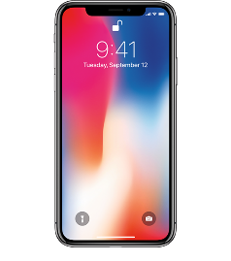 | Tablet
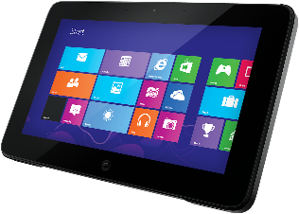 | Phone
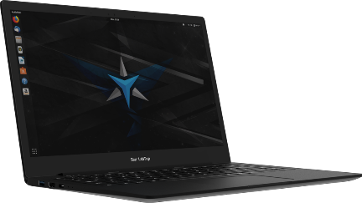 | Labtop
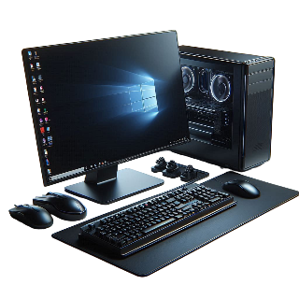 | Computer

Q2: Match the following:

 | This PC | 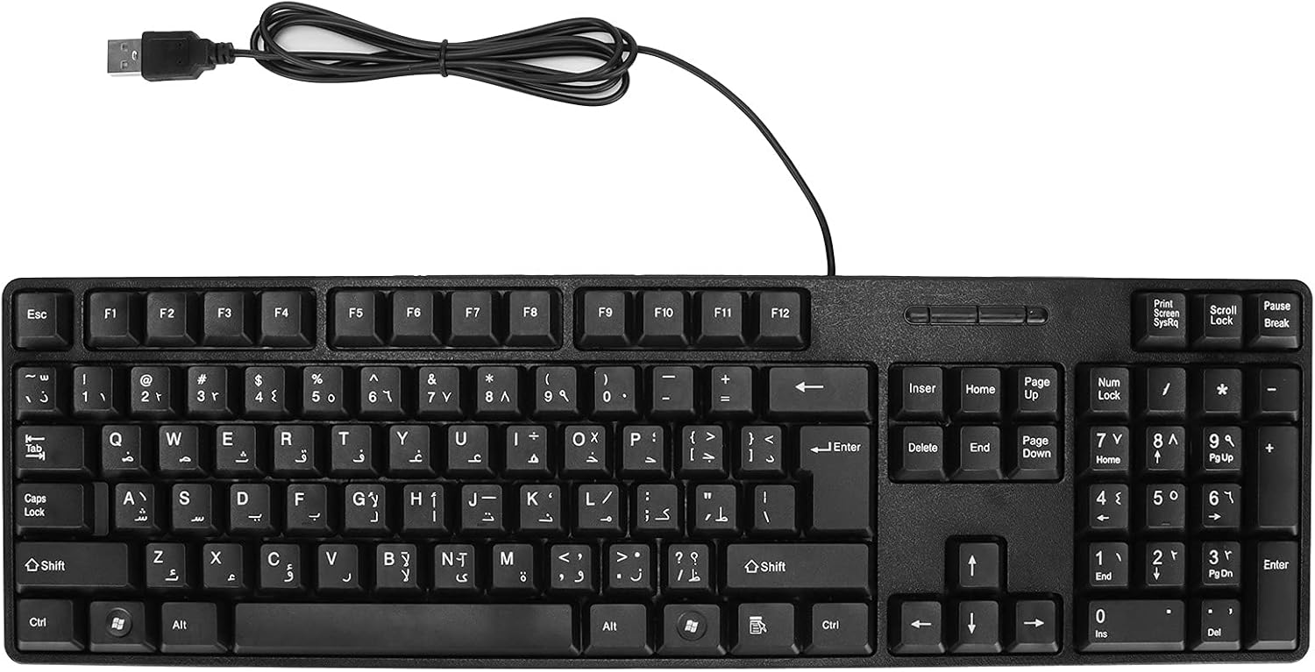 | Mouse
 | Folder |  | Enter
 | Notepad |  | File
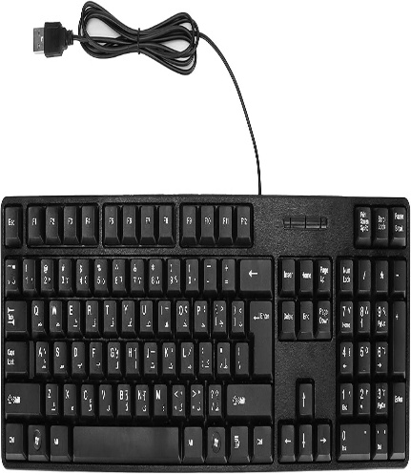 | keyboard | 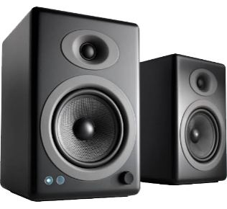 | Speaker
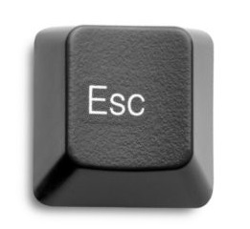 | Escape-key |  | Paint
Good Luck

